MY REWARD CHART
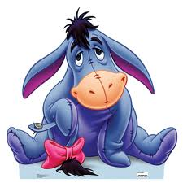

MON | TUES | WED | THURS | FRI | SAT | SUN

MY REWARD THIS WEEK WILL BE
IF I GET STICKERS

