MY REWARD CHART
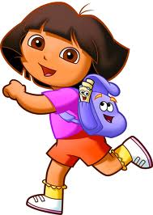

MON | TUES | WED | THURS | FRI | SAT | SUN

MY REWARD THIS WEEK WILL BE-
FOR GETTING STICKERS

